FOR IMMEDIATE RELEASE

Press Release –

Third Generation: The Bay Area Figurative Movement Today

Selected Bay Area Figurative Artists Exhibition

DATES
January 5-28, 2024

VENUE
Sausalito Center for the Arts, 750 Bridgeway, Sausalito, CA 94965

OVERVIEW
This co-curated figurative exhibition will be shown at Sausalito Center for the Arts in January 2024.
It features 18 Bay Area-based 2-D & 3-D artists who we have been invited to participate because of their important work as contemporary Bay Area figurative artists in the figurative community.

CURATORS
Susan R. Kirshenbaum and Catherine Merrill

Exhibiting Artists:
- Joseph Abbati
- Douglas Andelin
- Madelyn Covey
- Jane Fisher
- Mary Graham
- Isidoro
- Susan R. Kirshenbaum
- Catherine Merrill
- Stephen Namara
- Diane Olivier
- Sharon Paster
- Fernando Reyes
- Alex Rosmarin
- Randall Sexton
- May Shei
- Sandra Speidel
- Peter Steinhart
- Charles H. Stinson

CURATORIAL STATEMENT
Third Generation: The Bay Area Figurative Movement Today – Selected Bay Area Figurative Artists
The Bay Area Figurative Movement never died and continues to thrive. San Francisco Bay Area artists and models founded the Models Guild in 1946, and it’s no wonder that we still have such a healthy, lively community, chock-full of dedicated talent. Some of us even flourished during COVID and sheltering-in-place, as we continued drawing, painting, and sculpting on Zoom sessions around the world. What does our figurative community look like? We are artists and models; teachers and students; our styles are anywhere from classical to pop; our techniques are everything from digital to hand-ground pigments; and our community encompasses the very experienced and the relatively new to exhibiting. This exhibition explores a full range of styles and approaches combined with skill and craft.

Third Generation: The Bay Area Figurative Movement Today will be on view at SCA from Jan 5-28th, 2024.
- The Opening Reception will be held on Saturday, Jan 20th, 2 to 5pm. Refreshments will be served.
- The Closing Reception will be held on Sunday, Jan 28th, 3-6pm. There will be a book talk/sale, curators’ and artists’ talks, a roving model to draw, and more!

Contact Susan: srkirshenbaum@gmail.com or 415-425-3632.

A sample of one piece of art by each artist in the show appears on the following pages.

EXHIBITING ARTISTS’ SAMPLES OF WORK IN THE SHOW

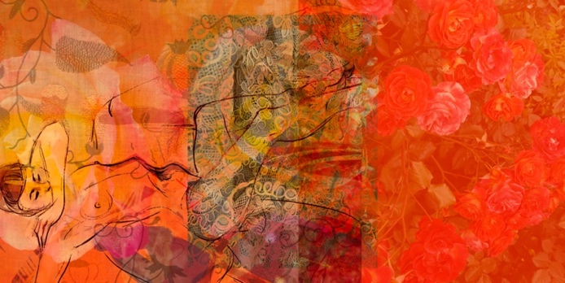

Susan R. Kirshenbaum

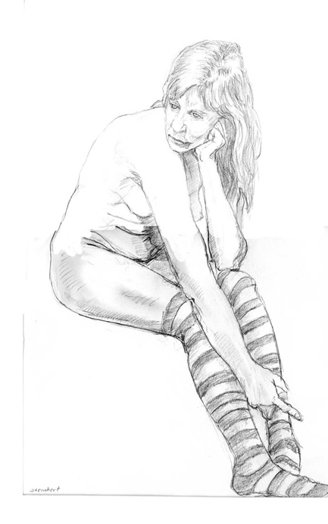

Peter Steinhart

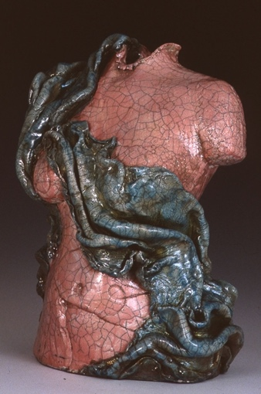

Catherine Merrill

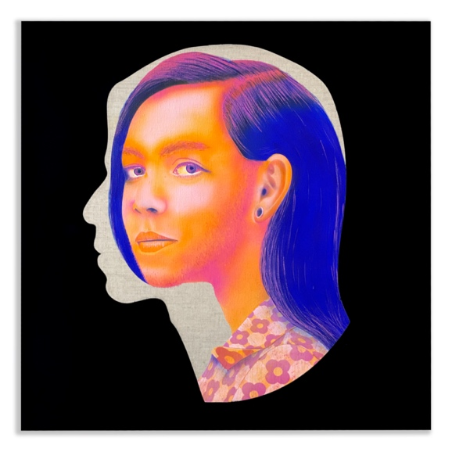

Joseph Abbati

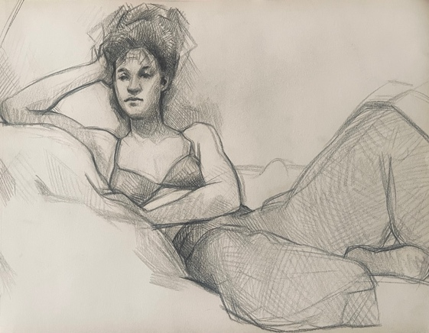

Alex Rosmarin

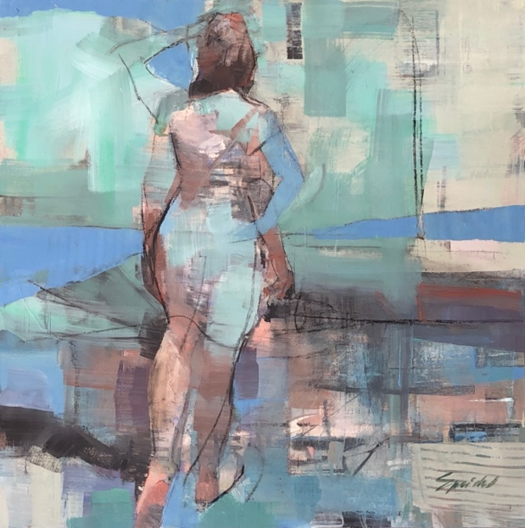

Sandra Speidel

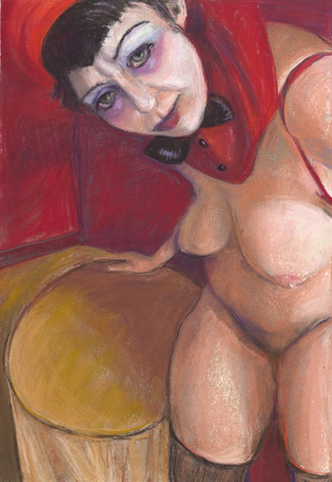

Diane Olivier

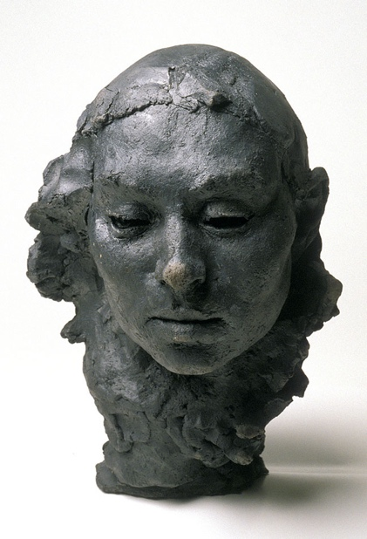

Douglas Andelin

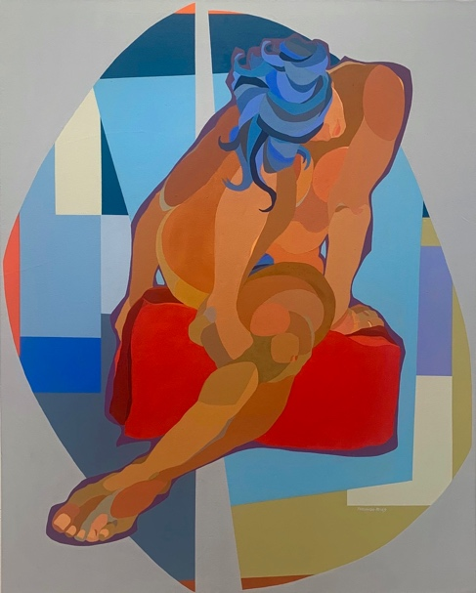

Fernando Reyes

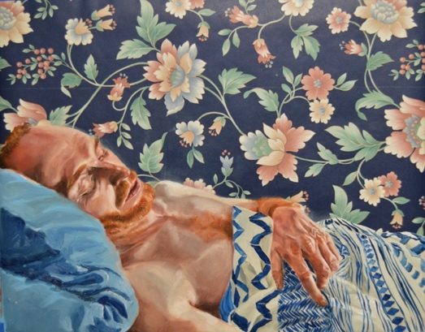

Madelyn Covey

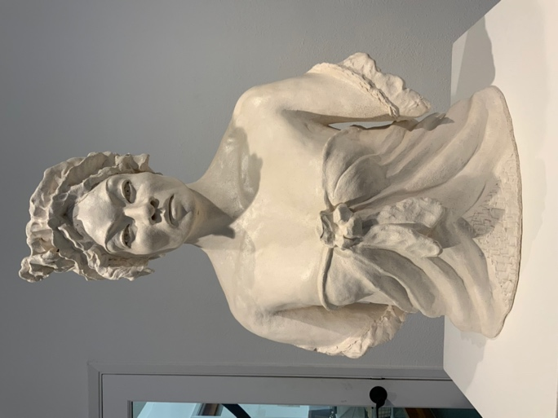

Isidoro

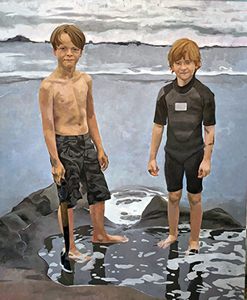

Jane Fisher

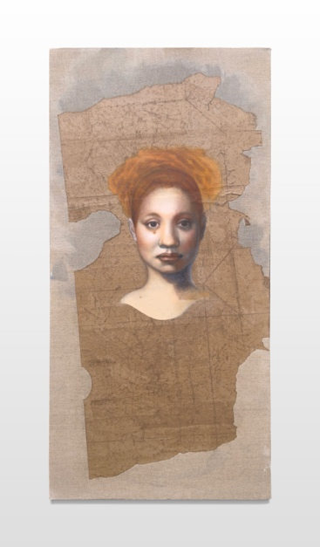

Mary Graham

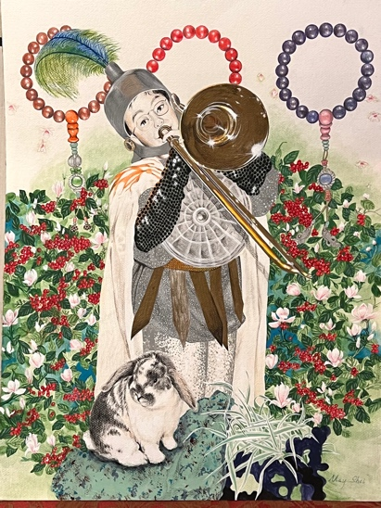

May Shei

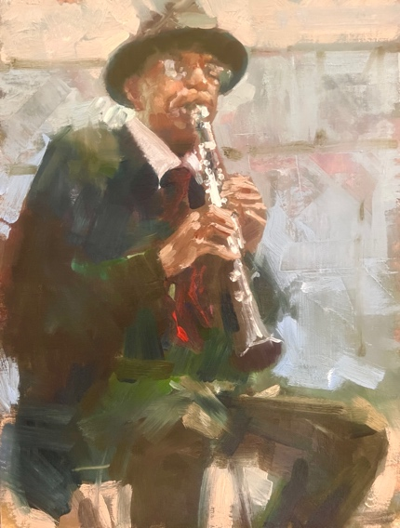

Randall Sexton

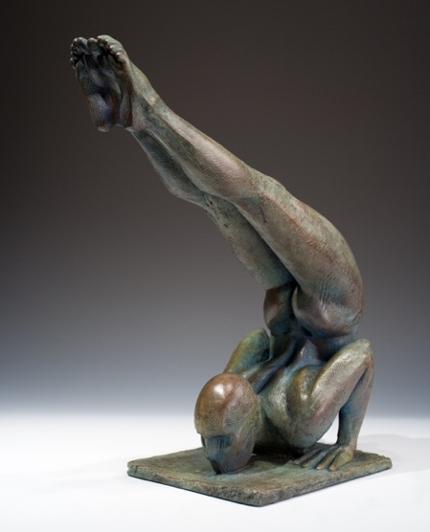

Charles H. Stinson

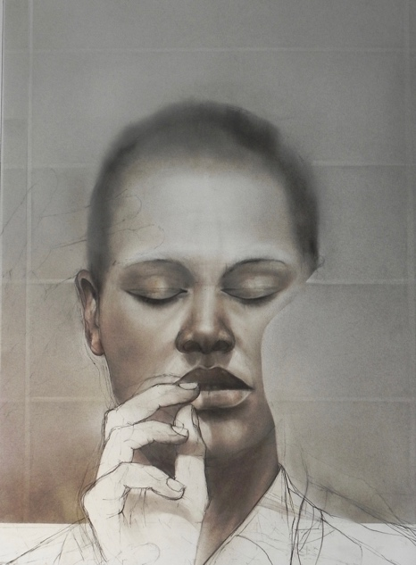

Stephen Namara

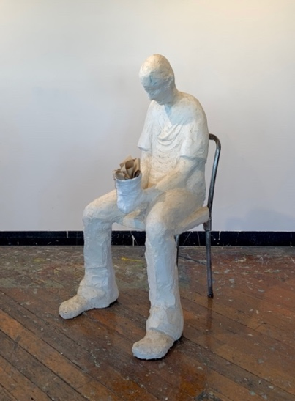

Sharon Paster

