6.1.24
Kindred Spirits
Mary Graham, Value Test: Brown Paper
View Exhibition
Author: Aliyah Dunn-Salahuddin

"It was a color thing and a class thing, And for generations of Black people, color and class have been inexorably tied together."
- Lawrence Otis Graham, Our Kind of People (1999)
‍
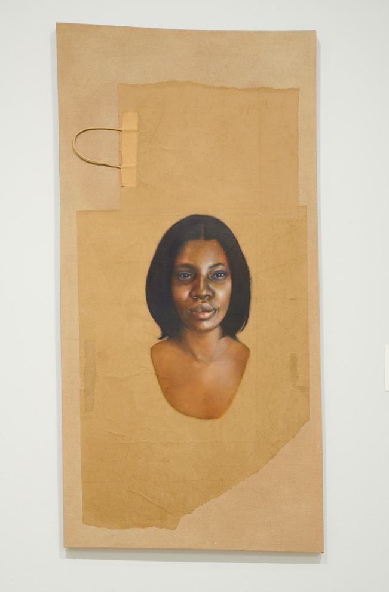
Mary Graham, Lewis (Part of series Value Test: Brown Paper, formerly known as Paper Bag Test: 21st Century), 2023. Oil on linen-mounted brown paper bag. 48 x 24 in. Courtesy of Bridget R. Cooks Cumbo, Ph.D.
‍Mary Graham’s Value Test: Brown Paper is an exhibition of fictionalized Black female figures brought to life through oil-based paint on canvases of brown paper bags. Some still containing the handles, the brown paper bags beckon the countless hands of Black women, who throughout history have been forced to carry the load. The “brown paper bag test” was a historical practice that denied access and entry of darker-skinned African Americans into social spaces, networks, and the familial lineages of more affluent lighter-skinned African Americans. African American scholar Lawrence Harper Graham explains, “one can find both pride and guilt among the Black elite. A pride in Black accomplishment that is inexorably tied to a lingering resentment about our past as poor, enslaved Blacks and our past and current treatment by whites.”¹ It is hard for most of us today to imagine living under the rigidity of Jim Crow racism, a system that denied humanity and access based solely on the color of one’s skin. In Jim Crow America, a black person risked their life if they made eye contact with a white person, did not step into the street when a white person passed them by, drank from a fountain, or entered an area designated “whites only;” essentially, it was a crime to be “colored.” Jim Crow was particularly insidious because it was the overt organization of society based on an ideology of white supremacy. When we take these realities into consideration, one can begin to understand why those who engaged and perpetuated acts of colorism, such as the “brown paper bag test,” did so.
‍
‍
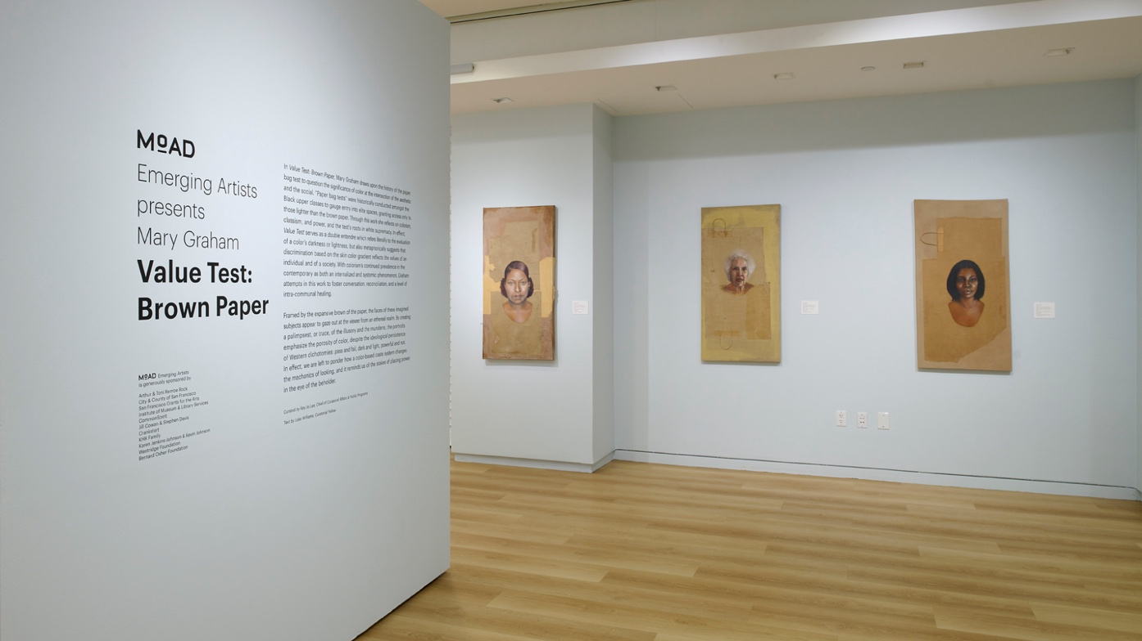
Mary Graham: Value Test: Brown Paper (MoAD 2024)
‍Graham's exhibition also forces us to ask why these practices persist on a global scale, and continue to disproportionately impact women of color. Colorism is a term that Alice Walker is credited with coining in 1982, and is defined as “prejudicial or preferential treatment of same-race people based solely on their color.”² Graham’s collection shows us that it’s much more than light or dark, black or white. She exposes the ways the seemingly mundane brown paper bag was used to stratify and assign human value based on false notions of color. With a focus on Black women, her paintings operate from the intersection of race, class, and gender. For Graham, the brown paper bag “is a representation of white supremacy in its most arbitrary sense, where it's simply a binary of pass or fail, dark or light, succeed or fail.”³

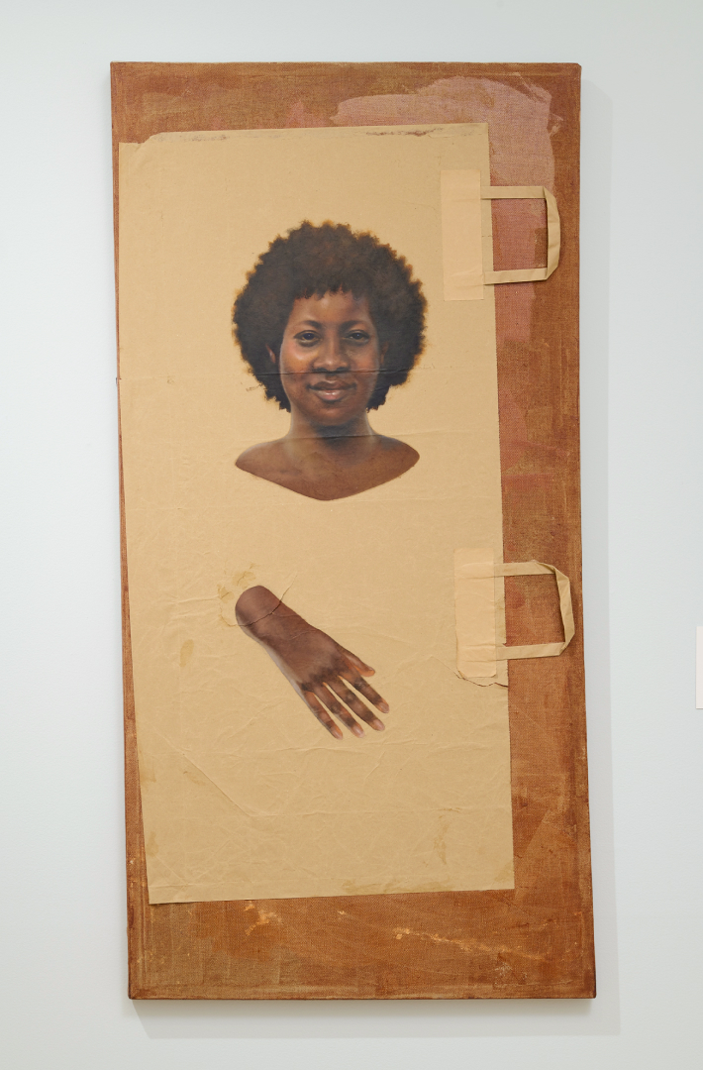
Mary Graham, Wheeler (Part of series Value Test: Brown Paper, formerly known as Paper Bag Test: 21st Century), 2023. Oil on linen-mounted brown paper bag. 48 x 24 in. Museum of the African Diaspora.
In Wheeler featured above, there is a hand that seems to come through the paper, evoking the time travel of Octavia Butler’s 1979 fiction novel Kindred. In the opening pages of Butler’s Kindred, Dana, the 26-year-old African American writer and protagonist “lost her arm on her last trip home,” “home” meaning the antebellum south, a place Dana was uncontrollably brought back in time to when the life of her white ancestor was threatened.⁴ Dana expresses the loss of her arm as painful, a part of herself forever lost, crushed under the weight of history and time. I wondered if, like Butler’s Dana, the beautifully rendered smile of Graham’s Wheeler hides a deeper pain. The figure in Wheeler is one of the browner figures with a deep mahogany brown complexion. Her hair, a textured and curly Afro that frames her smiling face, and brown eyes simultaneously illustrate the absurdity of the “brown paper bag test” and the beauty of Black femininity. Value Test: Brown Paper is a lesson in history and a call to action that celebrates our heritage and survival while being equally critical of it, so that no person of a darker complexion ever has to prove their worthiness, humanness, or right to belong. Our colors are something to celebrate, and one does not have to be African American to know, as Graham reminds us, that “our colors tell a story,” and have a history of their own.⁵
‍
‍

Excerpt from Sacramento Daily Union, Vol. 22, Number 22, No. 3306, November 1, 1861, California Digital News Collection.
‍
‍On October 29th, 1861, in San Francisco, George Gordon, an African American proprietor, was brutally beaten and killed in his own business by a white man named Robert Schell. From 1850-1863, the California State Legislature enacted laws that prohibited any “Indian,” “Black,” or “persons having one-half or more of negro blood,” from being a witness or testifying against a “white” person in court. This left Black businesses and establishments vulnerable to harassment and terrorism at the hands of whites, who were protected from prosecution under the law. In the case of Gordon, all the witnesses to his murder were identified as “colored,” and therefore barred from giving testimony against Schell, who murdered Gordon in broad daylight on the streets of San Francisco. However, there was one male witness, who was fair-skinned and recorded as wearing a wig. This witness was “passing,” meaning presenting and living as “white,” in essence performing race.⁶ The witness hoped his testimony would bring justice for Gordon. To determine his “whiteness,” the defense brought three southern doctors of racial science to San Francisco to act as expert witnesses. These “experts” examined the witness's eyebrows in open court with a magnifying glass to note the texture of his hair before taking him to a backroom of the courthouse to examine hair covered by the clothing on his body. It was determined that the witness was not white enough, and Schell went free.⁷ Proving one's proximity to whiteness, proving one's right to safety, humanity, and inclusion, as artist Mary Graham states, “pass or fail, dark or light,” was but one way that the illusion of white supremacy has been maintained through actions like the “brown paper bag tests.”
‍
Value Test: Brown Paper is also a deeply personal exhibition. The beautifully painted faces look at you and tell stories of grandmothers and great grandmothers with their gaze; some smile, while others look out onto the gallery with a strong conviction that comforts like an embrace, or the soft kiss of an elder on your cheek as you lean down to greet them after the long journey home. My own mother was born in San Francisco in the early 1950s. Her mother’s complexion was a deep, dark mahogany, and my mother’s skin was a light eggshell cream. Decades later, when my mother met my father in San Francisco, my grandmother expressed her disapproval because “he was too dark.” As I age, I have come to have empathy for my elders who imposed these ideals into me as child, ideals I had to untangle to understand my identity and how it is perceived by others. Graham’s paintings remind us that these ideas of color are tied to the origins of this country as well as to our own family histories.
‍
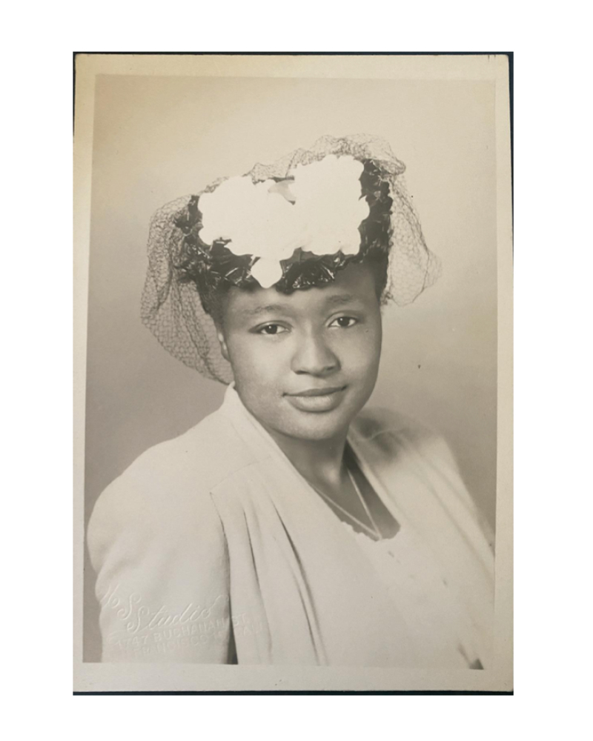
Della Mae Jones (1921-2000) Grandmother of author, Aliyah Dunn-Salahuddin.
‍
‍
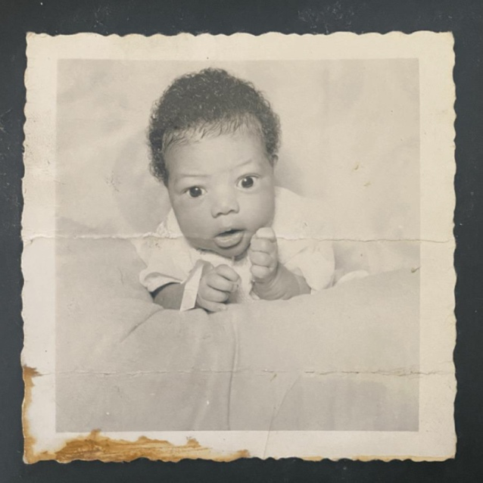
Yvonne Jones, (1951) Mother of author, Aliyah Dunn-Salahuddin.
‍Upon entering the exhibition, you become enraptured by the gaze of these women skillfully conjured from the artist's imagination and introspection. The paintings have an almost angelic, life-like quality; their eyes follow you through the exhibition and invite you to explore your own relationship to notions of color, class, and family. Mary Graham’s Value Test: Brown Paper is a celebration on brown paper bags reflecting the diversity and complexity of Blackness, the vibrancy of hues and hair textures, ages, body types, and features that stand in stark contrast to the uniformity and inexpensiveness of the brown paper itself. The brown paper bag exposed, ripped open, and reclaimed as canvas shows the fragility of the racial hierarchy and the importance of examining the tools and materiality of racial oppression. Whether we look back to the post-Reconstruction Era or at our present moment, color, something as innocent as the contents of a crayon box, remains a marker of power, privilege, and class in American society. Mary Graham shows us that only through looking back onto the kindred spirits of our pasts can we cultivate and reclaim the freedoms denied to those, who happened to be born “the wrong color.”
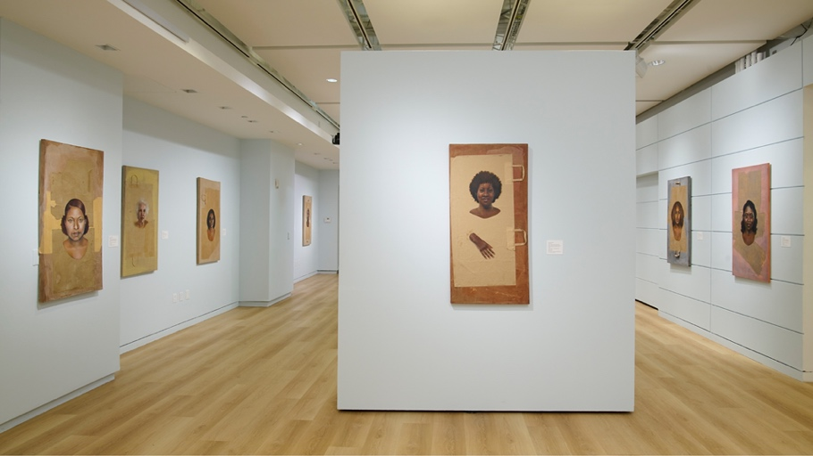
Mary Graham: Value Test: Brown Paper (MoAD 2024)
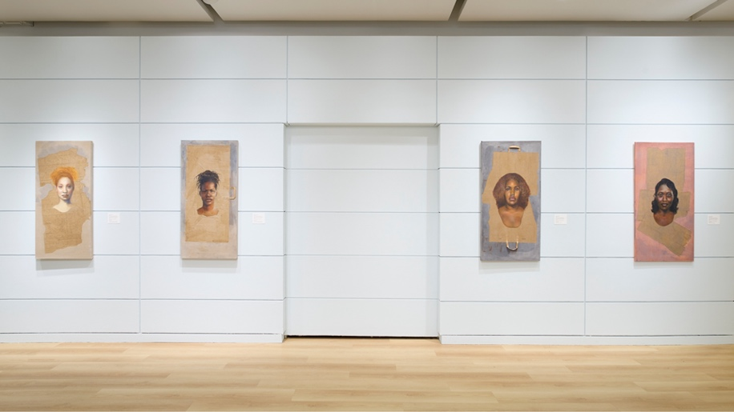
Mary Graham: Value Test: Brown Paper (MoAD 2024)
Citations
¹ Lawrence Otis Graham, Our Kind of People: Inside America's Black Upper Class (New York: HarperCollins Publishers Inc., 1999), 18.
² Kimberly Jade Norwood, “If You is White, You’s Alright...” Stories About Colorism in America,” Washington University Global Studies Law Review, Vol. 14, Issue No. 4, 2015.
³ Mary Graham, “Artist Activation & Reception: Mary Graham, Value Test Brown Paper Bag,” Museum of the African Diaspora (MoAD), April 7, 2024.
⁴ Octavia Butler, Kindred (Boston, MA: Beacon Press, 1979), 10.
⁵ Mary Graham, “Artist Activation & Reception: Mary Graham, Value Test Brown Paper Bag,” Museum of the African Diaspora (MoAD), April 7, 2024.
⁶ Allyson Hobbs, A Chosen Exile: A History of Racial Passing in American Life (Cambridge: Harvard University Press, 2015).
⁷ “The Crime of Testimony Laws,” Gold Chains the Hidden History of Slavery in California,” ACLU of Northern California; Also see Albert Broussard’s “Civil Rights, Racial Protest, and Anti-Slavery Activism in San Francisco, 1850-1865.”


Author
Aliyah Dunn-Salahuddin
PhD candidate of history: Stanford University

Aliyah Dunn-Salahuddin is a PhD candidate of history at Stanford University. Prior to entering Stanford University, she earned both her B.A. and M.A. in American History and a minor in dance at San Francisco State University. She went on to become tenured faculty at City College of San Francisco (CCSF) where she taught both African American and United States History. Her current research interests are focused on the African American experience in California and the Pacific Northwest. More specifically, her research centers on the intersection of racial and environmental inequality examining how those disparities are perpetuated through the building of urban infrastructure in San Francisco's Bayview-Hunters Point. Aliyah is also a dance performing artist interested in utilizing public history and the arts to make local histories more accessible to people outside academia.

